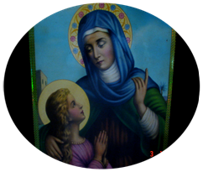

ST.ANN’S SECONDARY SCHOOL
P.O BOX 13106 MBEZI LUIS, MAKABE ROAD – DAR ES SALAAM
(SHULE YA WASICHANA)
Cell: 0686434577/0683178130
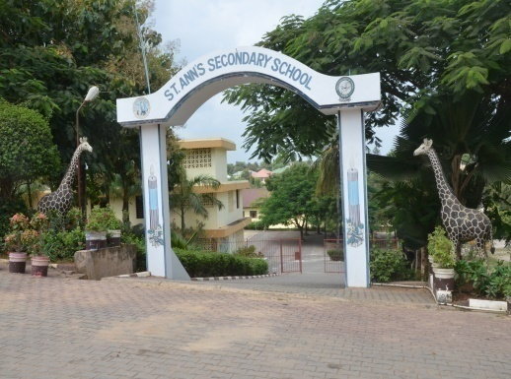
Inawatangazia nafasi za Kujiunga Kidato cha Kwanza (Form One) Mwaka 2026.
Mtihani wakujiunga na Kidato cha Kwanza Mwaka 2026 Utafanyika Shuleni na Msimbazi
Center Tarehe 20/9/2025. Baada ya hapo tutaendelea Kufanya Mitihani yakujiunga
kila Jumamosi hapa Shuleni. Form Zinapatikana Shuleni Na Msimbazi Center.
Pia Nafasi Zipo Kwa Wanaohamia Kidato Cha Pili (II) Na Cha Tatu (III)
- Ni Shule ya Bweni kwa Wasichana Tu.
- Ina Michepuo ya Sayansi, Sanaa na Biashara.
PRE FORM ONE COURSE ITAANZA TEREHE: 01/10/2025 HADI TAREHE 29/11/2025.
- Ni Shule Bora Kimaadili Na Kinidhamu.
- Inaendeshwa Na Masista wa Shirika la Mt. Anna
- Ni Kati Ya Shule Zinazofanya Vizuri Kitaifa.
- Shule Ipo Mbezi Luis- Barabara Ya Makabe.
- Ada yetu ni nafuu na inalipwa kwa awamu tatu.


ST.ANN’S SECONDARY SCHOOL
P.O. BOX 13106 MBEZI LUIS, MAKABE ROAD, DAR ES SALAAM
Cell: 0686434577 /0683178130
Email:stannsconventdar@yahoo.com

PICHA
S. No._____________________
STUDENTS APPLICATION FORM ACADEMIC YEAR 2026.

- STUDENT DETAILS:

FIRST NAME: ________________MIDDLE NAME: _____________LAST NAME: _____________
DATE OF BIRTH: ______________________ PLACE OF BIRTH: ________________
SEX: ________ RELIGION: ____________ NATIONALITY: _________________
FORM APPLIED FOR: FORM I _________FORM II __________FORM III__________
- DETAILS OF PREVIOUS SCHOOL ATTENDED BY THE APPLICANT

LAST SCHOOL ATTENDED _________________________________
DATE: FROM: ___________ TO___________CLASS COMPLETED____________
- PARENTS/ GUARDIAN DETAILS

NAME: FATHER /GUARDIAN__________________, NAME: MOTHER/GUARDIAN____________________
OCCUPATION: _______________________________, OCCUPATION: __________________________
PHYSICAL ADDRESS: ___________________________, PHYSICAL ADDRESS: ___________________ P.O BOX: ______________ P.O Box: ______________
MOBILE PHONE NO. _______________________ MOBILE PHONE NO. _________________

- STUDENT ACCEPTANCE/DECLARATION :

Full Name _________________________ Signature _____________Date __________________

- PARENT/GUARDIAN ACCEPTANCE

Full Name: _________________________ Signature _____________Date__________________

- ACADEMIC PERFORMANCE OF THE PREVIOUS CLASS

ANGALIZO;
Ambatanisha nakala (kopi) ya ripoti ya mwisho ya maendeleo ya kitaaluma ya mwanafunzi
Kutoka shule anayotoka.

ST.ANN’S SECONDARY SCHOOL
P.O. BOX 13106 MBEZI LUIS MAKABE ROAD, DAR ES SALAAM.
Cell: 0686434577/0683178130
Email:stannsconventdar@yahoo.com
2026

TAARIFA MUHIMU:
Mtihani wa kujiunga na shule utafanyika 20/9/2025, shuleni St. Ann’s pamoja na Msimbazi Centre kuanzia saa 3:00 asubuhi – 7:00 mchana
KIDATO NA MASOMO YA KUTAHINIWA
KIDATO I - Kiingereza, Hisabati na Sayansi
KIDATO II na cha III - Geo/History, Hisabati, Physics.
Matokeo ya mtihani yatatangazwa tarehe 22/9/2025, wanafunzi watakaofaulu na kuchaguliwa wazazi watajulishwa kupitia simu zao.
Siku ya mtihani wanafunzi watatakiwa kuonyesha vitambulisho vyao vya usaili kabla ya kuruhusiwa kuingia kwenye ukumbi wa mtihani.
Gharama za fomu ya maombi ni Shs. 20,000/= Fomu Zinapatikana ofisi ya shule siku zote za kazi, yaani Jumatatu hadi Ijumaa na msimbazi Centre Room No. 9, 12, 19, 22 na 25.
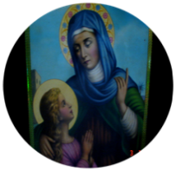
ST. ANN’S SECONDARY SCHOOL
P.O. BOX 13106 MBEZI LUIS MAKABE ROAD– DAR ES SALAAM
Cell: 0686434577

Tafadhali onyesha chaguo lako la lugha Tarehe: ……/….…./2025
Kiswahili English

PICHA
KITAMBULISHO CHA MTIHANI WA KUJIUNGA MWAKA 206
(Tafadhali onyesha kitambulisho hiki mlangoni)

Na. ya Fomu ……………………………………
Jina la Mwanafunzi ……………………………………………………………..
ANGALIZO:
Jumamosi, saa 3:00 asubuhi, tafadhali njoo na Kalamu, Penseli, Rula na Kifutio kwa ajili ya mtihani wa kujiunga na shule.

………………………………………………………
MKUU WA SHULE.

ST.ANN’S SECONDARY SCHOOL
P.O. BOX 13106 MBEZI LUIS MAKABE ROAD, DAR ES SALAAM.
Cell: 0686434577 / 0683178130
Email:stannsconventdar@yahoo.com

PICHA
MAFUNZO YA AWALI YA KIDATO CHA KWANZA - 2026
FOMU NO:____________
Jina la Mwanafunzi____________________________________________________
Tarehe ya Kuzaliwa___________________________
Mahali Alipozaliwa___________________________
Jina Baba/Mlezi______________________________________________________
Kazi ya Baba_______________________________ Sehemu ya kazi__________________________________
Jina la Mama____________________________________Kazi ya Mama______________________________
Dini_________________________________
Jina la Shule aliyotoka____________________________________________
Mwaka aliomaliza Darasa la Saba (VII)___________________________
Sanduku La Posta_________________________________
Namba ya simu ya Baba__________________________Namba Ya Simu Ya Mama___________________

Mafunzo ya awali ya kidato cha kwanza (Pre-Form One) yataanza tarehe 1/10/2026 hadi tarehe 29/11/2026
Shule yetu ni bweni na ni ya Wasichana tu.
Ada ya kozi pamoja na huduma za bweni Tshs: 350,000/=

Sahihi Ya Mzazi;…………………………………………..Sahihi ya Mkuu wa Shule .

